**CONCORDIA LUTHERAN CHURCH**

**ANNUAL PROGRAM REPORT 2023**

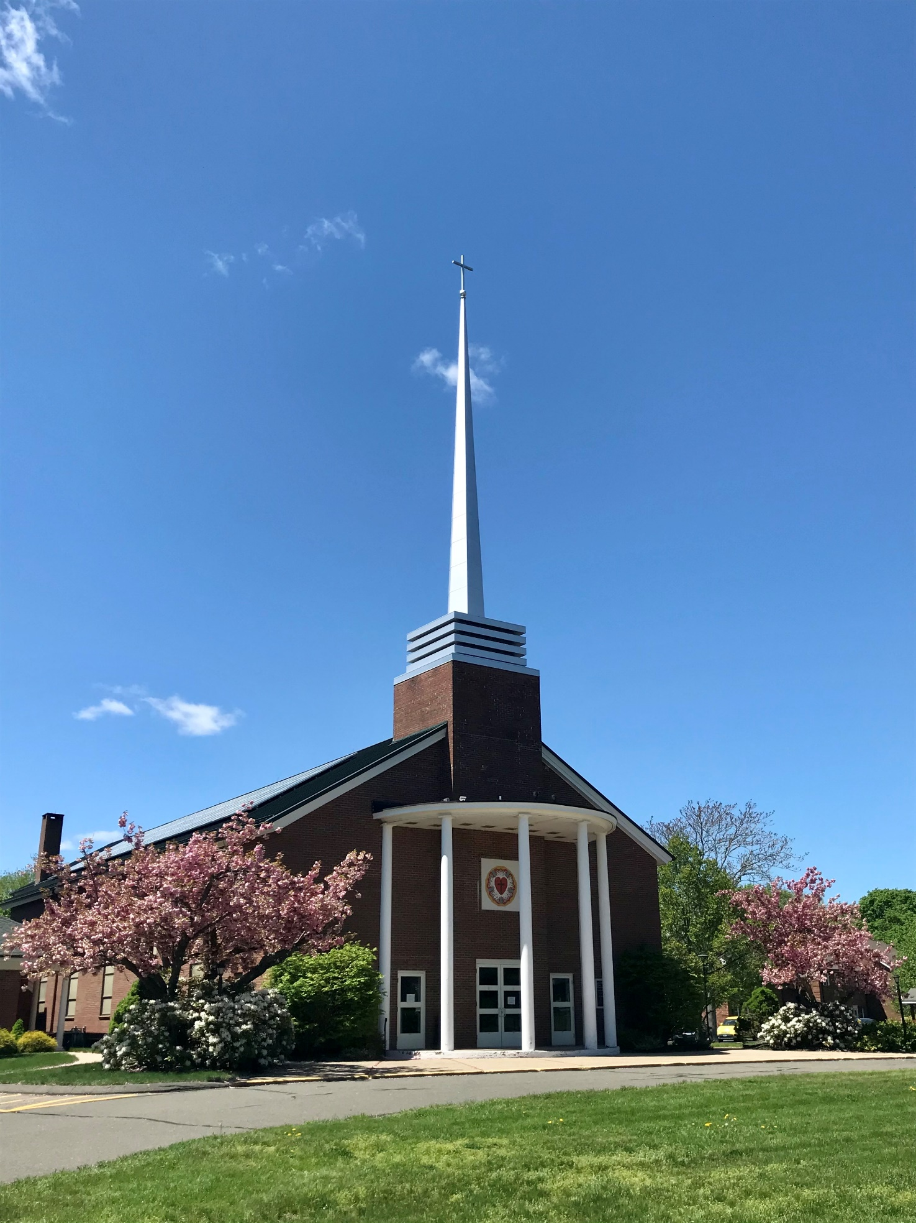

**In Memoriam**

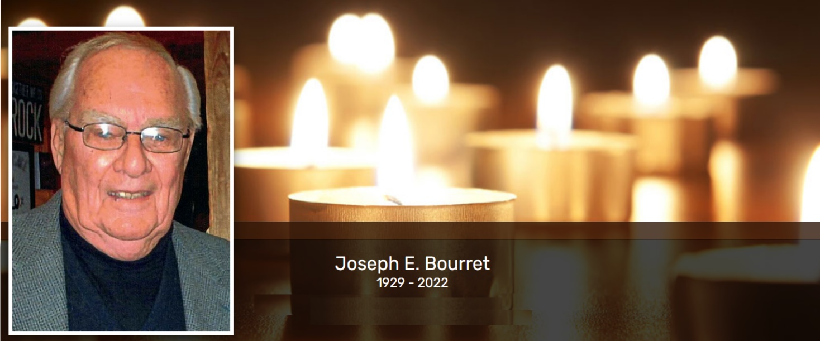

**Obituary of Joseph E. Bourret**

The Rev. Joseph E. Bourret, 93, of Glastonbury, Connecticut, died August 28, 2022, at home.

Born in Providence, Rhode Island to the late Nelson George and Helen (Nystrom) Bourret, he was raised in Cranston, Rhode Island. A 1954 honors graduate of Bethany College, Lindsborg, Kansas and a 1958 graduate of Augustana Seminary, Rock Island, Illinois, he funded his education working as a carpenter, sign painter, and as a radio broadcaster at WOC, Davenport, Iowa.

Ordained a Lutheran pastor in 1958, he served as pastor of several congregations in New Hampshire and Connecticut, continuing to serve the Church throughout his retirement. In 2006, he was named Pastor Emeritus of Concordia Lutheran Church in Manchester, Connecticut. In addition to his vocation in the Church, he worked in solar construction and radio broadcasting (WTIC and WKSS, Hartford). His many interests included woodworking, sailing, gardening, classical music, reading, and crosswords.

In addition to his parents, he was predeceased by his siblings Nelson, Jr. and Mary DeFanti.

He is survived by his beloved wife of 69 years, Patricia Konze Bourret; four children: Kristine (James Garofolo), Steven (Susan), Rebecca (Jeffrey Kinney), and Jon; six grandchildren: Jacob Kinney (Shanna Adrian), Michelle (Mark), Samuel Kinney (Morgan Hilliard), David Garofolo (Kaleigh Cragan), Hannah Kinney (Sammie Nichols), and Philip Garofolo; a sister, Elizabeth Robison; and numerous nieces, nephews, and cherished friends.

A memorial service will be held at Concordia Lutheran Church, 40 Pitkin St., Manchester, Connecticut, at 11:00 a.m. on September 16, 2022, with calling hours from 6:00-8:00 p.m. on September 15 and one hour before the service, also at Concordia Lutheran Church.

In lieu of flowers, memorial contributions may be made to The Lutheran School of Theology at Chicago (lstc.edu) or the ELCA World Hunger Appeal (community.elca.org/elcaworldhunger)

**JONATHAN STECHHOLZ OBITUARY**

STECHHOLZ - Jonathan, of East Islip, NY, on October 17, 2022, died in the Lord at the age of 72. Jon was born to Rev. Erwin and Myra (Behland) Stechholz in New Kensington, PA. Jon, an Eagle Scout and Honeoye Falls, NY High School Valedictorian, received a degree in Civil Engineering from Valparaiso University and a Masters from Bucknell University. Jon worked for Piper Aircraft and had a private pilot's license. He taught engineering at Bucknell University, and spent the majority of his career working for state and local highway departments. He was an avid Mets fan, Civil War history buff, and enjoyed college basketball. Jon was most known for his service to the church, with building and grounds maintenance, membership on committees and choirs, and served as a deacon. Jon is survived by a son,  
  
Dennis, and grandson, Hunter, of Manchester, CT, brother, Rev. Dr. David Stechholz, of Livonia MI, and sister, Mrs. Claudia Chiaro, of Rossville, GA, and their families. A memorial service will be held at Trinity Lutheran Church, 111 Nassau Ave., Islip, NY on November 3, at 11am. Memorial donations can be made to Trinity Lutheran Church. Arrangements under the direction of the Overton Funeral Home in Islip. [overtonfuneralhome.com](http://overtonfuneralhome.com/)

*Jon was a former member of Concordia and was interred in the Memorial Garden on Thursday, December 1, 2022 at 4:00p.m.*



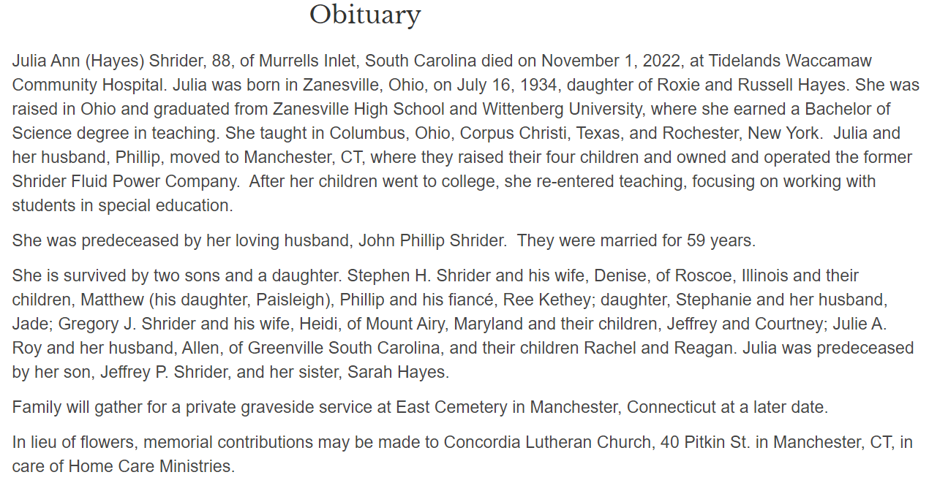

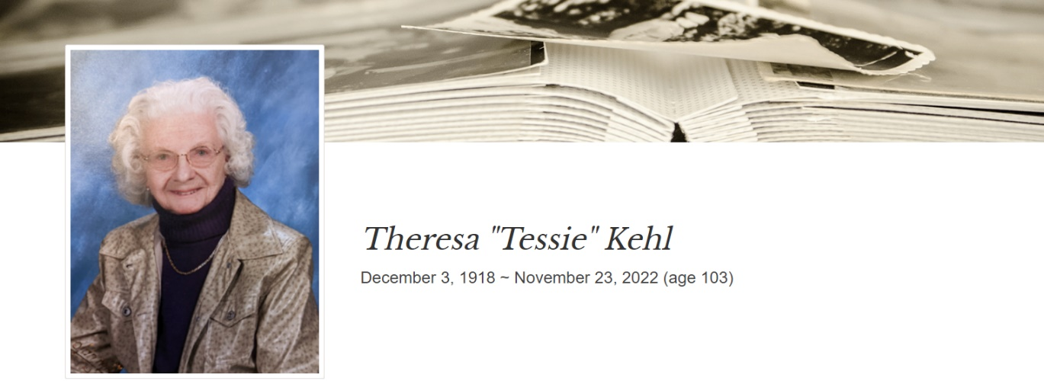

Obituary

Theresa Fischer Kehl died peacefully after a very long and fulfilling life at the age of 103, in Vernon, Connecticut on November 23, 2022. Theresa, who lovingly became known as “Tessie,” was born on December 3, 1918, to the late Anton Fischer and Theresa Bauer, in the small hamlet of Riggerding, Bavaria, Germany. When Tessie was a young girl, she and her family moved to a farm in Pleinting, Germany on the banks of the Danube River. Her father owned a butcher shop and gave it up to be a farmer. Tessie’s family home was in Reisach. In 1936, at the age of 18, Tessie came to the United States with the plan to work for a few years, save money, and go back to Germany. But by 1939, World War II had broken out in Europe, and she could not return home.

    Tessie met Edward Kehl in New York and they were subsequently married. She was unable to return to Germany until 1949. Tessie spent her working life in the retail grocery business. Her last position was with Mott’s Supermarkets as a traveling supervisor for the deli operations in all the Mott’s Supermarkets.

    Tessie and Edward resided for a while in New Jersey and in 1952 they moved to Manchester, Connecticut. Tessie and Edward were known for their cooking and baking at the Fastnacht celebration at Concordia Lutheran Church. Tessie was an amazing baker and was especially known for her delicious Christmas cookies.

    Tessie is predeceased by her parents, siblings, many friends, and her beloved husband, Edward. She is survived by her son, Douglas Kehl and his wife, Ann Kehl, of Glastonbury, Connecticut, grandchildren, and their spouses including, Laurie Wilhelm and her husband, John Wilhelm, Matthew Kehl and his wife, Jill Kehl, and Benjamin Kehl and his wife, Barret Katuna. She is also survived by eight great-grandchildren including: John D. Wilhelm, Meredith Ambrozaitis, Tyler Wilhelm, Chase Wilhelm, Megan Kehl, Sydney Kehl, Hans Kehl, and Henry Kehl. Tessie also is survived by very close family friends including Mark Winzler, Jane Casserly, and her goddaughter, Lisa Matteson.

    A memorial service will be held at Concordia Lutheran Church in Manchester, Connecticut located at 40 Pitkin Street, Manchester, CT 06040 on Thursday, December 29 at 2:00 pm. In lieu of flowers, donations can be made to the Concordia Lutheran Church Memorial Fund in her honor.

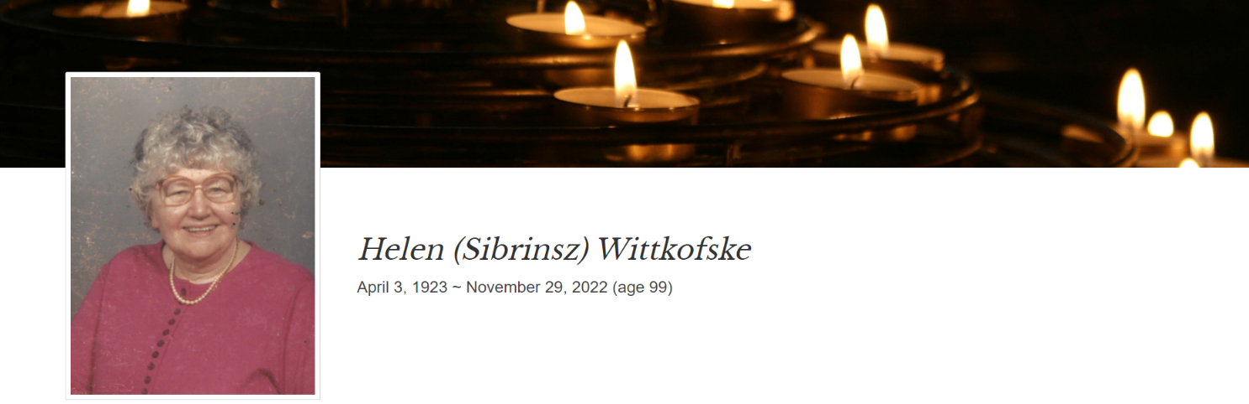

Obituary

Helen Sibrinsz Wittkofske, age 99, of Manchester, Connecticut, died November 29, 2022. She was born on April 3, 1923, daughter of the late Anna Minnich Sibrinsz and John Sibrinsz. Helen graduated Valedictorian from Manchester High School, Class of 1941. She was employed at Aetna Life Insurance Company for over 40 years, making numerous contributions. She took the flagging blood mobile, quadrupled blood draws, and wrote the manual for the first vanpool program. Aetna became one of the largest, if not the largest, van pooling company in the state. For 21 years, Helen volunteered at the Manchester Senior Center kitchen and the MACC food pantry. She also volunteered at Christmas in April luncheons.

Helen’s life was simple and revolved around her home, family, and her work at Concordia Lutheran Church. Helen taught Sunday school for 56 consecutive years as well as vacation bible school. She was a co-member of the nursery school board, belonged to the women’s group, taught First Communion, was a Confirmation Mentor, and belonged to the Outreach and Care Committee. She worked on a midweek program called LOGAS which included serving supper. She also worked at funeral receptions in the kitchen helping to make the food. From an early age, and for many years, she wrote notes, cards, and letters to people who were ill or housebound. They joked that the post office would always be solvent due to her writings.

Helen was predeceased by her husband Larry of more than 50 years, her siblings, John Sibrinsz, Ann Sibrinsz Smith, Michael Sibrinsz, and William Sibrinsz Sr. She was also predeceased by her beloved niece Dana Sibrinsz Husereau. She leaves 11 nieces and nephews, 14 great nieces and nephews, 12 great, great nieces and nephews, and 3 great, great, great nieces and nephew.

In her later years, nieces Robin Jackson, Leslie Grant, and Dana Husereau (until her death) were her faithful caregivers. The family would also like to extend a very special thank you to John Haid.

Services for Helen will take place on Tuesday, December 6, at Concordia Lutheran Church, 40 Pitkin Street, Manchester, beginning at 11:00AM. Burial is to follow in East Cemetery, 220 E. Center Street, Manchester. To view Helen’s tribute page or leave an online condolence, please visit holmeswatkins.com.

If she could speak at the end, she would like to remind everyone of Jesus’ saying “Love one another as I have loved you”…..Rest in Peace.

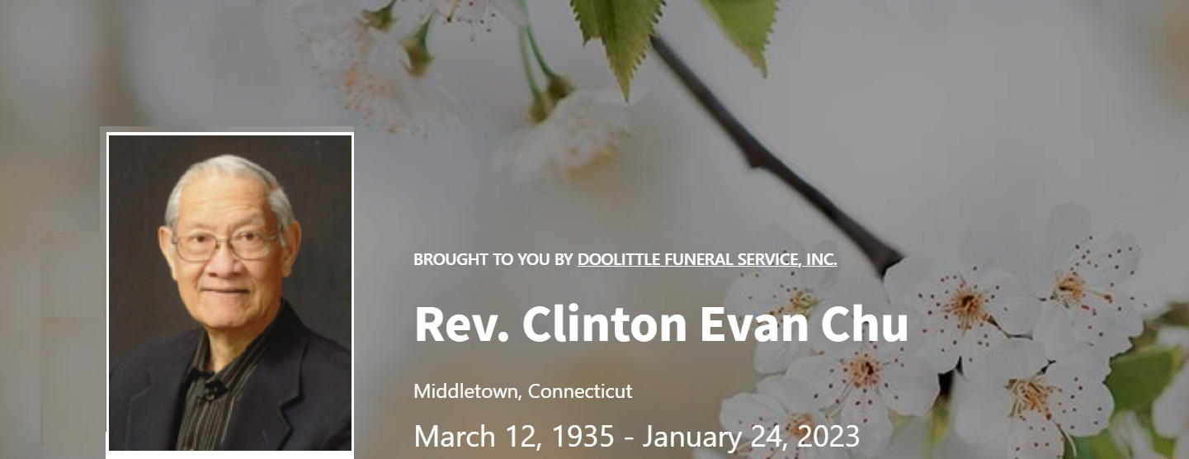

**Obituary**

Rev. Clinton Evan Chu, 87, of Middletown, Connecticut passed away peacefully on January 24, 2023 to join the Eternal Kingdom of God in Heaven.  He was the beloved husband of Shirley (Singh) Chu for over 59 years and the devoted father to daughters Sharon Chu and Sandy (Chu) Sponzo.

Born on March 12, 1935, in New Amsterdam, Guyana, South America, he was the eldest of three sons to the late Cyril S. Chu and Esther Kim Ho-You.  He was a graduate of Wittenberg University and Hamma Divinity School in Springfield, Ohio and was ordained in 1960 as a Lutheran minister in the United Lutheran Church in America.

Clinton’s career as a Lutheran minister spanned over 37 years serving in the following parishes: St. John’s Lutheran (Oahu, Hawaii), St Mark’s Lutheran (Portland, Oregon), Lutheran Church in Guyana (multiple parishes), St. Thomas Lutheran (Jamaica, New York), St. Peter’s and St. John’s Lutheran (Luthersburg, Pennsylvania), Prince of Peace (Altoona, Pennsylvania), St. Luke, Cassville, and Mount Zion (Mount Union, Pennsylvania), St. Peter’s and St. John’s Lutheran (Milroy, Pennsylvania).

Clinton’s passion for serving the Lord was evident in all that he did and he touched the lives of many, both in active ministry and in retirement.  His grace, compassion and cheerful smile greeted everyone who came in contact with him.  He provided inspiration, joy and comfort to all who came to know him.  His passion for ministry was only matched by his love and dedication for his family.

He will be deeply missed and fondly remembered by his family and friends.  In addition to his wife, Shirley, and daughters, Sharon of Durham, CT and Sandy of Windsor, CT, he is survived by his sons-in-law Michael P. Giardina and Michael J. Sponzo, grandson Michael E. Sponzo and nephew, Brian Chu.  He is predeceased by his brothers Dr. Aubrey Chu (Ardsley, New York) and Hector Chu (Yonkers, New York).

The family would like to thank all of Clinton’s doctors, nurses, and care professionals who took such tremendous care of him especially during the last year of his life.  He and the family were especially grateful for the excellent care and compassion provided by Hartford HealthCare Heart and Vascular Institute, Middlesex Hospital, and the Connecticut Oncology Group.

A celebration of Clinton’s life is planned for February 11, 2023 at 10:30 am at Zion Lutheran Church, 183 Williams Street in Portland, Connecticut with Rev. Sara Stall-Ryan officiating.  In lieu of flowers, memorial contributions can be made to Zion Lutheran Church, P.O. Box 202, 183 William St, Portland, CT.  To share a memory or leave condolences, please visit www.doolittlefuneralservice.com.

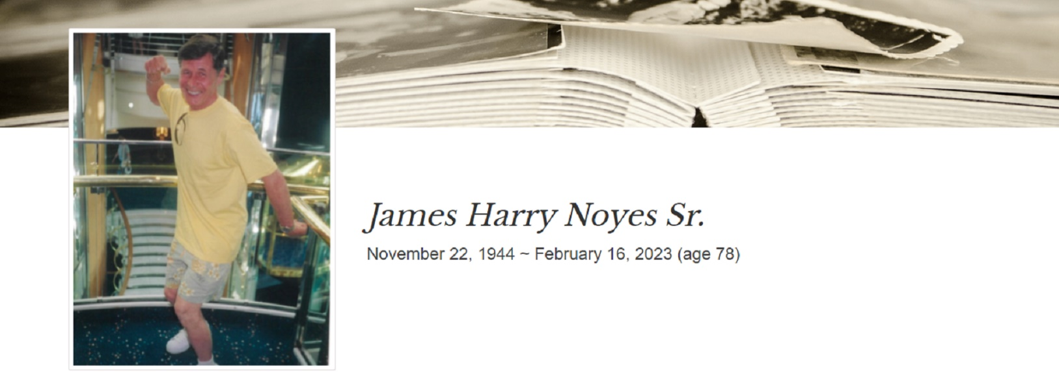

James Harry Noyes Sr., born November 22, 1944 was brought home to the Lord on February 16, 2023. Born to the late Harry D. Noyes and Mary A. (Taylor) Noyes, James attended Windham Tech High School, and later served in the U.S. Army during the Vietnam War. After his honorable discharge, James worked as a machine repairman at Mal Tool engineering where he was a supervisor for over 40 years.

He is predeceased by his two sisters, Anganette Sites formerly of Maine, Elaine Patrone formerly of East Hartford, CT and Ralph Noyes Sr. (Patricia) of Georgia.

He is survived by his wife of 54 years, Kathy Noyes. His two sons, James H. Noyes Jr. of Coventry and Joseph E. Noyes of Coventry. His daughter, Katherine M. Noyes-Parsons of Vernon. He also leaves behind two sisters, Carolee Yeske of Enfield, CT and Mildred Kervin (Fred) of Windham. In addition, he is also survived by three grandchildren, James H. Noyes III of Hebron, Samantha Lee Noyes of Florida and Kayden J. Parsons of Vernon, along with several nieces and nephews.

Calling Hours will be held at Holmes Watkins Funeral Home, located at 400 Main Street, Manchester CT 06040 on Monday, February 20th from 6pm till 8pm. A Funeral Mass will be held on Tuesday, February 21st at Concordia Lutheran Church, located at 40 Pitkin Street, Manchester CT 06040 at 10am with Military Honors to follow. Burial will be private at a later date.

In lieu of flowers, donations can be made to Manchester Area Conference of Churches MACC Food Pantry, 466 Main Street Manchester, CT 06040, and St. Jude Children’s Hospital.

**Semi-Annual Congregational Meeting**

**June 11, 2022**

**Call to Order**

**Devotions**

**Approval of Agenda**

**Approval of Minutes- January 2023 Semi-Annual Meeting**

**Reports**

* Pastor
* President
* Nursery School Director
* Christian Education
* Ministerio Nueva Creación
* Treasurer Update on Budget
* GHIAA
* Stewardship
* Outreach
* Worship and Memorial Garden
* Member Care
* Property

**Elections**

* Congregation Council
* Legacy for Ministry
* Memorial Garden Board

**Transition Update**

* Partnership with Ministerio Nueva Creación

**Information**

* The Nominating committee for 2024 elections will be appointed at the January 2024 Semi-Annual Meeting. The January 2024 Semi-annual meeting will tentatively be held on January 21.
* The Congregation Council will meet after this meeting to elect officers.

**Adjournment**

**Unapproved Minutes of the Concordia Lutheran Church Annual Finance Report 2022 held January 29, 2023**

**Call to Order –** David Smith @ 11:39 AM

**Devotions –** Pastor Hedberg

**Approval of Agenda – It was moved, seconded and voted to approve the Agenda**

**Approval of the Minutes of the June 26, 2022 Semi-Annual Congregational Meeting – The minutes were approved as written.**

**Reports**

**Pastor’s Report –** no additional comments

**Council President’s Report –** David Smith added emphasis to the following:

* The special thank you to Pastor Rolf Hedberg for agreeing to share his many pastoral talents with Concordia for as long as we need them.
* Thanks to Jane Geason, our very competent Parish Administrator for agreeing to stay in her position through June of 2023. We hope that she agrees to stay even longer.
* Our participation with Ministerio Nueva Creación, (MNC), in the Hispanic Heritage Festival, the seminar on Christmas Traditions of the Latine Community, the “Fun, Food and Fellowship” and the opportunity for the women of Concordia to join MNC’s Women’s Group activities.
* Concordia’s successful Stewardship response and that Concordia has been fortunate to be able to welcome new members.
* David reviewed the council officers elected last June, they are as follows:

President – David Smith

Vice President – John Corl

Secretary – Susan Bourret

Treasurer – Carol Stoneman

* David also mentioned the recent Wartburg Seminary Zoom Presentation on Latinx and Anglo congregations worshiping together that many from Concordia and MNC attended.
* David asked all of us to read the Some more thanks…. Paragraph in his report.
* And last but not least David reminded us that Fastnacht was returning this year.

**2022 Year End Treasurer’s Report –** Carol Stoneman summarized the report and stated that report was a good snapshot of the 2022 yearly finances. Carol highlighted the following:

* That envelope and stretch offerings exceeded the budget by 4% and that $800 of the stretch funding was designated Thrivent gifts from Thrivent members.
* Carol reminded us that there were plots and pie charts that illustrated the income and expenses.

**Legacy for Ministry Report –** David Smith pointed out that with the interest rate going up long term bonds were not presently a good investment. Therefore, Legacy has converted these funds to short term bonds and to Fidelity Total Market and International Index Funds. David also reviewed the

**Worship and Memorial Garden Report**

David thanked Gail Adams for volunteering to be the Worship and Memorial Garden Treasurer for the report and alluded to it being a lifetime job, to much laughter.

**Concordia Nursery School Finance Report –** David stated that the Nursery School does a good job adhering to their budget.

**Report from the Stewardship Committee –** David Smith went over the report, pointed out that some pledge units increased their pledges and thanked all for their giving.

**Reception of all of the Reports –** **There was a motion to receive all of the reports, the motion was seconded and the vote passed.**

**Motion regarding Property Repairs –** **Entrance Canopy Roof Replacement –** The motion and repairs were explained.

**The motion was seconded and passed.**

It was mentioned that Linda Cherry has indicated that her husband James would have wanted his memorial gifts to go to this project.

**Approval of 2023 Proposed Ministry Budget –** Carol Stoneman handed out a revised budget sheet. In going through the Budget Revenue Carol pointed out the following:

* That since only one AA Group was using the building, instead of two, the revenue projection is down.
* That the major reason that the proposed budget expenses for Staff Salaries and Fringe Benefits for 2023 were projected to be lower is that in 2022 the budget included a Transition Pastor for half of 2022 and a half time Pastor for the other half of 2022. The 2023 Proposed Budget contains the expenses for a Transition Pastor for the entire year.
* The projected deficit for 2023 is $11519.00, Carol reminded us of the projected $40,000 deficits that we have dealt with in the past and have overcome.

**It was moved, seconded, and the motion passed to adopt the Proposed 2023 Budget.**

**Election of Synod Assembly Voting Members**

Tina Sollinger-Ruggerio and David Smith were elected as the voting members.

**Appointment of Nominating Committee**

Jan Salvatore, David Smith, and John Corl were appointed to the nominating committee.

**Adjournment –** a motion to adjourn passed at 12:43 PM

**Why Statement**

TO be a welcoming and inviting community empowered by the Word of God

SO THAT we may work for social justice and exhibit compassion for all.

**Mission Statement**

As Lutheran Christians, Concordia understands God is calling us to be:

A Christian community with responsibility to support each other, our neighborhood and the larger community,

A gathered Assembly marked by the practices of prayer, study, reflection and worship,

Selfless Disciples who communicate and practice the faith through acts of faithful stewardship, service and forgiveness.

Respectfully submitted,

John Corl

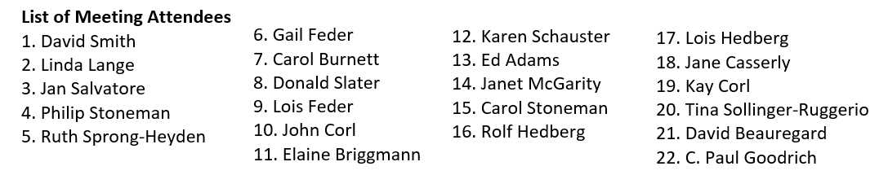

**A Pastoral Letter for the June 2023 Semi-Annual Meeting of the Congregation**

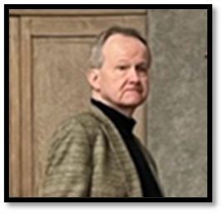Friends in Christ,

If I were to give this report a title, it would be this: ‘The Journey Continues’. This is good news. We are here. We are working towards a future. And probably best of all, as one door closed with St. Mary’s, we are diligently exploring a relationship with Ministerio Nueva Creación (MNC).

To that end, several things have happened and are happening along this journey. Perhaps one of the best things that continues to be a mainstay of the relationship with MNC is the Wednesday Bible Study which has been by Zoom until Covid restrictions ease up a bit. We have also participated in worship services together with not only people attending from both communities but Bea Santiago, their lay minister at MNC participating in the liturgy. One of the highlights of this was a joint Good Friday worship among Concordia Lutheran, Emanuel Lutheran & MNC and the specific liturgical act of the veneration of the cross from the tradition of MNC. In addition to Bible Study and worship experiences, women from the two communities have also socialized together. And beyond that we have gotten together for food, fun, fellowship and games after worship. More to follow I am sure.

But in addition, the Church Council of Concordia attended a three day worship (via Zoom) led by Rubin Duran which was sponsored by Wartburg Theological Seminary in Iowa. The purpose of the workshop was to begin to help us explore the cultural realities that need to be explored to seek a better understanding of things shared in common as well as differences. We also traveled to Providence, RI to meet with the people of Gloria Dei Lutheran Church and to listen to their experiences of transitioning between a Swedish Lutheran Congregation and an Hispanic Congregation. We plan to meet with their pastor, The Rev. Rodriguez again in the future.

So as you can see, a lot has been done, but the greatest challenge lies ahead of us. This will not be easy. Looking to the future there are some things that present some very major concerns. Not the least of which is an aging congregation and the attending financial concerns. This is not doom and gloom; it is reality. And the other part of the reality is whether or not we either have the will power to make these things happen or do we even want to see some kind of transition happen.

I am sure that you all have thoughts and feelings about what you want to see happen. This is very understandable and I do not this in a condescending way. It is just the way it is.

And so I would hope for two things – The first is near term and it is this: When asked for your constructive thoughts around this matter of Concordia’s future, you will be honest and direct. Your input is very important. Second, keep your church in your prayers and especially keep your leadership (Council and Officers) and the Transition Team in your prayers. It is a critical moment in the life of Concordia and we must trust not only the Holy Spirit but also each other for guidance in the transition process.

In Christ,

Pastor Rolf L. Hedberg

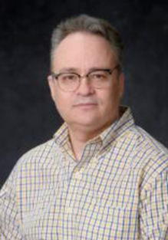**Congregation President’s Report**

It’s hard to believe it’s been a year since being voted in as council president. It’s been an honor to serve, and I’m pleased to report that we’re in a good position to discern where the spirit is calling us and to make decisions about our future.

Of note, we’re continuing to explore partnership with Ministerio Nueva Creación and are following the transition process, which included outlining our Strengths, Weaknesses, Opportunities and Threats (SWOT) for consideration in assessing the viability of a partnership and outlining areas where there’s synergy among the congregations and other areas that may need more discernment.

During Holy Week, we saw a glimpse of some changes in how we do things together with the inclusion of Spanish lessons and hymns. As an example, we included a tradition Ministerio Nueva Creación has of venerating the cross on Good Friday in leaving rocks at its base to signify individual prayer requests by ‘leaving it at the cross’. We saw members of the congregation approach the cross and pray in this fashion. It added a further element of solemnity to the service.

This year we will continue our transition work to explore and document the particulars of the partnership with Ministerio Nueva Creación, and we’ll rely on our Transition Team to lay out the next steps and formulate the plan for the congregation to consider as we move forward. We are working towards defining what the partnership would look like and have planned opportunities to do more events together, including supporting the Manchester Latin Affairs Council at this year’s Hispanic Heritage Day in September and planning the Three Kings Day service and event for next January.

Concordia is a house of worship and community. Within its walls there’s the Concordia Nursery School. On Saturday afternoons, the Christian Indian Church worships in the Bourret Garden Room, as does Ministerio Nueva Creación on Sundays. AA meets at Concordia on Monday afternoons.

We continue to support our ministries such as Member Care. We also have members in leadership with the Greater Hartford Interfaith Action Alliance (GHIAA), and we support Cub Scout Pack #144. The Worship and Memorial Garden remains beautiful, thanks to the work of the garden board. The church building and grounds remain beautiful as well, and in good repair thanks to our Property Committee, and to the volunteers that mow the lawn.

Our financial records are in good shape thanks to the work of the Finance and Legacy committees, our Treasurer, Assistant Treasurer, and Financial Secretary. We remain operating within our budget. This fall there will be a Stewardship program.

I’m happy to report that Jane Geason, our Parish Administrator, has agreed to stay on the job beyond June 2023. After taking the summer off, she will resume work in September and continue through April 2024, working three days per week. During July and most of August, Zach Baranowski will be filling in to provide coverage.

I would like to say a special thanks to Pastor Rolf Hedberg who has agreed to stay with us as Transition Pastor for ‘as long as we need him’ and this provides us with pastoral leadership and care as we move forward in our transition journey.

On behalf of the Council, a sincere thanks to all of you for your ongoing commitment and support to Concordia.

Some more thanks…

* Thanks to Mark Winzler for ensuring we have pastoral coverage and music ministers for our services. As a Council, it’s always great to know we are covered for the foreseeable future and we’re not having to scramble to find pastors or organists to cover our services.
* Thanks to John Haid who faithfully handles the sound system for our worship services and also records the worship liturgies for us for use in Holden Evening Prayers, for example.
* John Anderson and Linda Hilliard who have served us faithfully and well as our supply organists/choir director. Our rich worship and music life continues on!
* Thanks to Susan Bourret, Ruth Sprong-Heyden and Carol Stoneman who week after week have worked behind the scenes on offering counting, paying bills, and keeping a keen eye on our finances.
* Thanks to the property team of Joel Baranowski, David Beauregard, John Corl, and Phil Stoneman for their leadership in the care of our building and grounds. David is the point person for the outdoors activities ensuring our grounds are in pristine condition. Joel, John, and Phil work cooperatively inside. Joel writes the best and most detailed status reports on property issues/improvement projects.
* Thanks to my fellow members of the Transition Team (Mark Winzler, Susan Bourret, John Corl, Pastor Rolf Hedberg, and Carol Stoneman) for the time we have spent working this year on all aspects of the transition. It has been indeed a blessing to work together as we discern what God has in store for Concordia in the future.
* Thanks to all members of Concordia for being diligent and supportive financially and for your patience and understanding as we navigate the “new normal” in church and for your willingness to be open and flexible as we continue to discern our future.

A reminder that the Council serves as your representatives. As such, please always feel free to come to us with questions, suggestions, concerns, inquiries, and the like. Communication is the beginning of understanding.

We thank you for the opportunity to serve God as Council members!

On behalf of the Council,  
David Smith  
Council President

**Concordia Nursery School**

Semi-Annual Report

May 21, 2023

We began our school year in September with a return to relative “normal”. The acute impact of Covid on daily operations was significantly less this year. Children were now able to be vaccinated and masks were no longer required. Other than a brief surge in January we did not see widespread Covid infection and families were comfortable with less-restrictive policies. We continued to follow all CDC and Office of Early Childhood recommendations for best practices around disease prevention and infection control and the result was fewer missed days for both students and staff. While Covid remains present in our community, we seem to have reached the “new normal” level of response which suits our program and families’ expectations well.

Our groups of children, while smaller than in years past, were joyful, enthusiastic, and became close knit over the course of the year.

Once again, we began the year with the same teaching team of Kayle Gagnon, Ashley Salerno, and Laura Hart. Our team took great pride in cultivating a warm, nurturing school environment while planning creative, child-centered curriculum for the children in our care.

While many aspects of life have returned to normal, the nursery school has seen a significant decrease in enrollment over the past 18 months. Both classes were not fully enrolled. The 3-day class had 9 children (out of a possible 18) and the 2-day class had 10 (out of possible 15). Several families did not return and instead sought programs with longer hours, more days, and/or programs to meet their children’s unique developmental needs. Enrollment for the 2023-2024 school year is following this trend as well. Many low or no-cost options for preschool are now available in Manchester and the wider community through magnet and charter schools. Families have been impacted by inflation and there are fewer full-time stay-at-home parents who can bring their children to a program with the hours we have at Concordia. As we head into next year, creative thinking and potential changes to our schedule or target population will need to be considered for the school to remain viable.

Our finances heading into 2022-2023 were robust enough to support ongoing operations despite working with a deficit budget. We have previously received aid in the form of PPP loans (since forgiven) in 2020 as well as generous grant money in 2021 from the State of Connecticut for program support including payroll, staff wages, facility maintenance (including Covid PPE/cleaning supplies), and staff training. These funds helped fill budget gaps caused by the pandemic last year as intended. For 2022-2023, the state earmarked grants specifically to support childcare workers due to widespread staffing shortages in childcare programs statewide. We received generous staff retention bonus money. While greatly appreciated, did not help with any budget gaps this year given its restrictions that it be used solely for staff bonuses. We are finishing the year with a significant deficit and will require supplemental funding from the church to operate next year as our cash reserves are significantly decreased. We are thankful that the church is committed to helping us stay open next year and recognize that without increased enrollment the future of the nursery school beyond next year is in question.

We continue to give thanks for the generous support of the church and our program through Legacy Funds. We are proud to be able to offer financial support for families who would otherwise be unable to attend our school. This year we assisted 3 families with $5750 in aid.

We are also thankful for the ongoing support we receive from Jane in the office, treasurers Carol Stoneman and Susan Bourret, Nursery School Board members Sandra Baranowski and Julie Chiffer, as well as Church Council members and other parishioners. Many thanks to all, especially the building and grounds members who take such good care of our beautiful facility inside and out!

We realize that there are changes ahead for not only the nursery school, but the church as well. It is my hope that we will accept these changes with an open mind and faithful heart. While this special place is still here, I will continue to cherish the work we do and the opportunity to work with wonderful teachers, children, and their families.

Respectfully submitted,

Laura Hart

Director

**Treasurer Update on Budget**





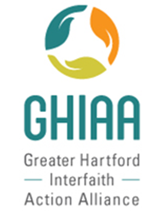**Greater Hartford Interfaith Action Alliance (GHIAA) Annual Report - June 2023**

Concordia continues to support Greater Hartford Interfaith Action Alliance (GHIAA) financially and by participating on the work being done. House meetings with hundreds of faith community members telling their personal stories were held. Analysis of the concerns voiced in these meetings resulted in identifying five issues to address this year. Issues were communicated with GHIAA members and Action Teams were formed to work on the 5 areas listed below as our 2023 slate.

GHIAA 2023 issue slate

* Mental Health
* Environmental racism
* Education Equity
* Housing and homelessness
* Gun Violence

Action teams worked to encourage legislators to submit and pass bills impacting these issues. Letters were written, phone calls were made and meeting with legislators held. The following bills directly impact these issues:

* HB 6633 - Fair Share Zoning reform
* HB 6664 - Trash issues, MIRA Plant clean-up
* HB 5003 - Education funding - Cost Sharing formula
* HB 6616 - Husky Health coverage for immigrants through age 18
* An Appropriations Committee allocation of $17 million for gun violence prevention

These bills are currently before the legislature and directly address the issues identified by GHIAA.

Concordia and Ministerio Nueva Creación (MNC)’s GHIAA teams have participated in house meetings, analysis of results, the GHIAA Power Summit December 7, 2022 and GHIAA Day at the Capitol, May 3, 2023.

We ask for congregational support of this work. Please write your legislators in support of these bills. If you don’t know who your legislator is, we can provide you with that information. Please feel free to contact one of us if you have any questions about the work GHIAA does or want to know how you can participate.

Respectfully,

Your GHIAA team,

Nancy Lynn Knauff, David Smith, Carol Stoneman and Susan Bourret

**Report of the Stewardship Committee**



**Based on the gift each one has received, use it to serve others, as good managers of the varied grace of God.** – 1 Peter 4:10

We are thankful for the continued leadership we have with Pastor Rolf Hedberg. The Stewardship Committee will be meeting in June to plan out our program to carry us through 2023 and into 2024. Care to join us? As a committee, we can always use fresh faces and new ideas. It is not a very large time commitment, and we’d love to have you.

As the year began, we were pleased with the tremendous response to our Stewardship program. We remain in gratitude for the members who increased their pledges this year, and for those who maintained theirs, and of course, for all who give of themselves to maintain our beautiful church and its ministries in thanksgiving to God. We’re thankful to those who continue to maintain the church building and grounds, see that the bills are paid, and ensure we can continue to worship as a community of faith.

We have a resounding faith that will maintain and look after the church and our members. We are entering a new chapter this year as we plan for the future. We will also be on the lookout to help those less fortunate in our community and to reach out and make connections with our neighbors to attract those in need of church.

Respectfully submitted,

The Stewardship Committee

Pastor Rolf Hedberg

David Smith, Chair

Carol Stoneman

Nancy Lynn Knauff

**Report of the Outreach Committee**

**“*As Lutheran Christians, Concordia understands that God is calling us to be:***

***A Christian community with responsibility to support each other, our neighborhood, and the larger community”***

**MACC Seasonal Sharing**

Through your generosity of purchasing food, Christmas gifts, delivering to the families and an overwhelming amount of monetary donations, along with the Concordia Nursery School and Ministero Nueva Creación, we were able to provide food for Thanksgiving and Christmas dinners (and then some), plus gifts of clothing, toys and gift cards to 21 adults and 25 children for our 10 MACC families. As usual, we provided home baked sweetbreads **at Thanksgiving and cookies at Christmas from** our “Concordia bakers”. A big ‘thank you” to Karen Schauster for continuing to provide “extras” for each basket.

*The* ***MACC 2022 Annual Report*** *is available in the office upon request.*

**Highland Park Elementary School**

Due to your generosity we were able to fill the request for numerous $25 gift cards to various grocery/retail stores for the families in need at Thanksgiving and Christmas. Many thanks to everyone at Concordia and the students and parents of Concordia Nursery School for collecting waterproof mittens and gloves, hats, socks and underwear for the students of Highland Park Elementary School.

On April 26th, Concordia hosted a “Teachers’ Appreciation” tea for 28 teachers of Highland Park School. The teacher supplies collected by Concordia were distributed at the tea.

A very heartfelt “Thank you” for your continued support for this very important ministry of Concordia. During the up-coming year we will continue to support our mission partners and will also look for additional opportunities to serve the community.

Respectfully submitted,

Outreach Committee

**Report of the Worship & Memorial Garden Board 2022-2023**

Our new lilac tree is blooming as I write this. The original tree was planted in 1997 and died.

Susan Bourret brought an offshoot of one of her lilacs, it was planted, watered and seems to be alive and well. Also, during the summer, we applied some polymeric sand to the beginning of the cross walkway to try & keep weeds from growing between the stones. This seems to have worked so we will continue to apply polymeric sand to the other areas of the cross walkway this summer. This year we will be spreading more mulch.

Last fall we had our first ground internment, Jon Stechholz. Also, in the fall we had a leak in the irrigation system. We immediately shut off the system & Frank’s Irrigation fixed the leak. This June we will inter Tessie Kehl in the wall. We had to find a new engraver for Jon & Tessie’s niche covers since our engraver had shoulder surgery & has not fully recovered yet. The Kehl’s and Wittkofske’s pathway stones are being engraved.

During the winter, the Board came up with questions for an attorney in the event we close & need to move people’s remains. Mark contacted Attorney Ryan Barry and Susan & I had several conference calls with him. There doesn’t seem to be any law or a precedent for moving the remains of people interred at Concordia over to East Cemetery and Attorney Barry is looking into logistical concerns.

The Rules & Regulations of the Garden Board did not contemplate the sad event of our closing. Susan agreed to review the Rules & Regulations. Now that the Garden is established a few minor wording changes were made and a new section added about liquidation. Since the Rules & Regulations mentioned people making arrangements in their wills for ashes to be interred at Concordia, we decided a letter needed to be sent asking for people’s final wishes. Based on our transition and unsure future, we needed to know who wanted ashes returned to them, whose ashes would be moved to East Cemetery if we close, and who was interested in reserving a niche for the future. April 15 was the response due date of the letter. Now we have an accurate count of ashes being returned, moved, and future committals. Council did pass a motion that it would pay for a plot at East Cemetery. The names of those being interred must be provided when a plot is purchased at East Cemetery. A cremation certificate is required upon interment. The Rules & Regulations are still under review, awaiting the Attorney who is looking into a trust that money could be put in for expenses that would be incurred after we close.

Thank you to everyone who weeds, mows, and waters! Thank you to Gail Adams for keeping our financial accounts straight. Thanks to David Beauregard for continuing to mow the Garden even though no longer on the Board. We are short one Board member, please consider joining us.

Respectively submitted,

Ruth Sprong Heyden, Chair

Board Members: Paul Goodrich, Susan Bourret, Edna Nekiunas, Jan Salvatore, Jan Bellino, Phil Stoneman, and David Smith our secretary

**Member Care**

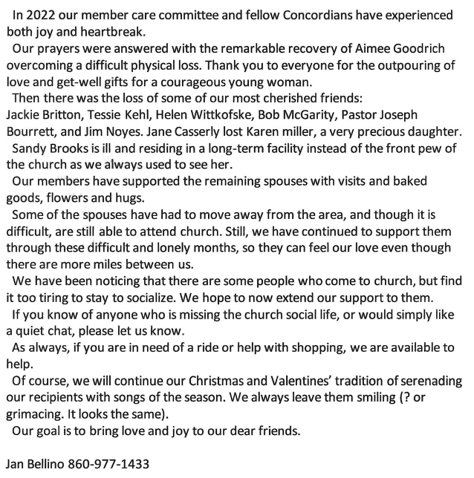

**2023 Semi-Annual Meeting Property Report (as revised by the Team)**

**Tasks, not in any special order, Completed since June of 2022**

* David Beauregard recruited the lawn mowing team for 2023. It consists of David Beauregard, Phil Stoneman, and Don Slater. **To give them a break once in a while more volunteers would be welcomed.**
* Using a rental hydraulic lift device West Electric secured the Nave chandelier that was hanging from a wire, replaced the chandelier incandescent down lights with LED lights and confirmed that the other 12 lights in each of the chandeliers were also LED lights. Using the same lift device, West Electric also removed steeple lighting electrical equipment on the portico roof in preparation of the re-roofing of the portico and replaced the lights, on the underside of the portico, that light the entrance with LED lights.
* The portico was re-roofed by Millstream Construction
* Joel Baranowski reviewed the open items from the May 2022 annual inspection with the Deputy Fire Marshal and all items were checked and accepted.
* Another 90-minute Emergency Lighting test was performed by Joel and again it required that Phil Stoneman get more batteries for the Emergency Lights and install them.
* Phil replaced some of the pavers outside the church entrance with Joel’s help.
* Joel and Phil replaced the doors to the dumpster fence and repaired and stained the fence.
* A furnace pressure gage has been installed
* The leak in the pipe to the NE hose bib was repaired and insulation was installed in the closet to prevent further freeze ups. Since that was not sufficient to prevent a further leak the pipe must be drained in the winter, see Pending Tasks.
* The outdoor faucet hose bibs were replaced at the northeast and southwest corners of the building
* A photosensor, that controlled the lights on the east side of the Garden Room, was replaced.
* The photosensor on the south wall (exterior) of Kaiser Hall was replaced
* A leak in the toilet in the Kaiser Hall Women’s Restroom was resolved by replacing a seal.
* A leaking flush valve was replaced in the office area bathroom
* Laura Hart reported that she had trapped some mice in the Nursery School cloakroom so Joel set several more mouse traps. Checks by Phil and Joel found no more mice.
* Joel and Phil Cleaned soiled carpet and washed the walls in one of the classrooms

**Tasks Required for Regular Upkeep and Operation**

* Landscaping duties: lawn mowing, weeding and trimming of the bushes
* Maintenance checks of the HVAC System in the fall and spring by All Seasons Mechanical. The fall check is for the heating startup and any required maintenance. The spring check is for the maintenance of the AC system and the shut-down of the heating system. The check of the AC system took 8 hours, with Phil in attendance, since it is the first time it had been done since its installation.
* Monthly check of the emergency lights by Phil, the Master of Darkness
* Phil periodically checks that the outside doors are locked
* Phil sets the timers for the outside lights and the Carillon for the seasonal time changes.
* Addressing building problems pointed out by staff and members.
* Phil periodically checks the interior of the building for problems.
* Yearly, 90-minute checks of the Emergency lighting

**Pending Tasks, in no special order,**

* Install steeple lights on the portico roof
* Install several ball valve isolation valves and a drain valve in the domestic water system, including a main shut off valve to isolate Concordia from the Town of Manchester
* Fix the Steeple leaks by replacing the steeple base flashing and sealing the brick
* Seal the roof leak over the entrance to Kaiser Hall

**Outstanding Tasks, in no special order,**

* Repair three of the four entrance doors
* Remove one of the handles from all of the exterior double doors for safety
* Scrape/sand and paint the railings along the walk way to the office
* Repair the concrete walkway by the office columns
* Make the general sidewalk repairs that are required around the facility.
* Repair the columns in the front of the church
* Repair and repaint the ceiling soffit at the portico canopy outside the sanctuary
* Clean and paint the outdoor signs
* Complete the indoor signage started by Dan Burnett

Respectfully submitted by John Corl for the Property Team,

Joel Baranowski, David Beauregard, Phil Stoneman and John Corl

**Transition**

As the last part of our transition activities, near the end of 2021, the congregation came to consensus to investigate possible partnerships with both St. Mary’ Episcopal Church and Ministerio Nueva Creación. After the Transition Team’s initial conversations with MNC and St. Mary's in December-January 2021/2022, the team felt that the best partnership might be for the three of us to partner.

As St. Mary’s was in the final stages of its own discernment, we waited until their vote which took place in March 2022. After a more than 30-year relationship, the members of St. Mary's decided not to partner with us, but rather pursue merger with St. John’s Episcopal in Vernon.

As a result of this, contact was made with Associate to the Bishop for Mission Kim Bergstrand to gather information about a possible partnership with Ministerio Nueva Creación (MNC) which is a SAWC (Synodically Authorized Worshiping Community) of the New England Synod. Kim first met with the Transition Team and shared some initial documents.

These documents were shared with Council. Kim met with the Council on March 21, 2022 at which time she provided further information and answered questions. The Council met again on March 28 to discuss what had been learned.

As part of the discussion of the partnership with MNC was the fact that if indeed "down the road" (whenever that would be) we decided to partner, Concordia members would need to consider undergoing "radical redevelopment" meaning that Concordia would become a church "OF" Manchester (more reflecting the population) rather than a church "IN" Manchester.  If that were the direction, then we would have to look at calling a Pastor/Redeveloper who had bilingual skills OR a Pastor/Redeveloper coupled with a bilingual consultant.

But, before we even "go there", we need to see whether the partnership between MNC and Concordia is a viable one (on both sides), hence the social and other activities which have taken place and the workshops attended have been a means by which Concordia and MNC members can get to know one another better and to gather information.

At its April 21, 2022 meeting, the Council put together a list of some items to discuss with Ministerio Nueva Creación (MNC) about a partnership/possible redevelopment of Concordia. Those were reviewed at the Council’s May 12 meeting and sent onto Kim Bergstrand.

Members of the Congregation Council and leaders of MNC met on Sunday, June 5 with Kim Bergstrand. The Council prepared a Partnership Statement the following which we shared with the MNC Leadership. They, in turn, shared their partnership statement with us. As a result, Concordia Council and MNC Leadership worked together to form the following:

*WHY/Purpose Statement/ La declaración de por qué / Propósito*

*To be a welcoming, inclusive and inviting faith community, empowered by the Word of God, walking the journey together, so that we become a beacon of hope, breaking down barriers, with compassion for all.*

*Ser una comunidad de fe acogedora, inclusiva y atractiva, empoderada por la Palabra de Dios, caminando juntos en la jornada, para que seamos un faro de esperanza, rompiendo barreras, con compasión por todos*.

At the June, 2022 semi-annual meeting when the MNC partnership was being discussed, there was a suggestion that before/as we explore this partnership and meet together with members from MNC for serious and focused discussion, that we have a meal together this summer or early fall.

In speaking with Kim Bergstrand about this, she endorsed that doing some social or other mutual activities together would indeed be a positive thing to do and for the next months it would be very appropriate to do things together socially and collaboratively and that focused discussion could take place in 2023.

As a result, Concordia and MNC worked together on Manchester’s Hispanic Heritage Festival, not just on the day, but in the planning over a couple of months. Over 20 Concordians either helped plan, work that day, or came to the festival to support it.

Concordia members have been invited to and some participate in Bible Study planned and organized by MNC on many Wednesday evenings

Concordia and MNC jointly attended a Saturday program sponsored by Wartburg Seminary on Christmas Customs in the Latine community. Almost 20 people attended the zoom presentation and shared lunch together.

In December members of Concordia and MNC participated in “Food, Fun and Fellowship” which people to learn more about each other etc. in a social atmosphere. Feedback was extremely positive.

At the end of January some members of Concordia (Pastor and Lois Hedberg, Jan Bellino, Sandy Baranowski, Susan Bourret, Ruthie Lynch, John Corl, Carol Stoneman, David Smith and Mark Winzler) along with Bea Santiago (MNC) attended a 3-part presentation by Wartburg Seminary on starting a Latine Ministry. This is part of an ELCA Churchwide effort to “activate ourselves so that more people may know the way of Jesus and experience community, justice and love.” (Note: The second part of this presentation will be held over three days June 1-2-3. Some of the people listed above will be attending this follow-up as well.)

The Transition Team met in January to review all of that which has taken place since last spring and reached out to Kim to talk about next steps. Additionally, we spoke about the need to continue to grow the relationships more. We also talked about the suggestion made at the semi-annual meeting that Concordia members be offered the opportunity to participate in a multicultural awareness program as a part of our consideration of partnership.

The Transition Team and MNC Leadership met on Sunday, February 13 to plan two more activities together.

* Soup and bread lunch on Sunday, March 26
* Food, Fun and Fellowship on May 21.

Right now we (Transition and Council) continue to focus on the partnership aspect with MNC (which the congregation came to consensus on).  No decisions have been made about moving forward with radical redevelopment as that is a congregational decision.

To that end, in addition to the social activities, the Council has been working on the following steps:

The Council gathered to put together Council will participate in a **SWOT** analysis

* **S**trengths
* **W**eaknesses
* **O**pportunities
* **T**hreats (Barriers)

This then was mailed to all members of the congregation and reviewed with them at a meeting on April 16.

These then were sent to the Rev. Santiago Rodriguez, Pastor of Gloria Dei Lutheran Church in Providence, Rhode Island to provide him with some background about the thoughts from Concordia’s leadership.

Pastor Rodriguez, his wife Keila (active in the ministry there) and a group of 10 members met in Providence on Saturday, April 22 with the Council/Transition and MNC leaders to talk about his journey as, under his steady and loving hand, Gloria Dei Lutheran Church changed from an entirely English speaking/Swedish Heritage Church into one which became a bilingual, multicultural congregation (Latine and White).

Pastor Rodriguez, Keila and members were able to share firsthand how this transformation/redevelopment took place.

This visit prompted more questions. To that end, Concordia and MNC leaders will hold another 2-hour Zoom meeting with Pastor Rodriquez, Keila members on Tuesday, June 20 to gather more information.

This visit also highlighted that we (Concordia) do not know the needs of the Latine community in Manchester and that a mechanism needs to be put into place in order to become educated about those needs.

Once this is completed, Associate to the Bishop for Mission Kim Bergstrand will then meet with the Council to debrief and talk next steps.

As always, information and progress will be shared with the congregation. Please feel free to reach out to members of the Transition Team at any time with questions.

Peace,

Transition Team

Susan Bourret, John Corl, Pastor Hedberg, David Smith, Carol Stoneman, Mark Winzler

**Nominating Committee Report**

*To be completed at the Annual Program Report Meeting on June 11, 2023.*